**DAY 4**

1. List all customers and the products they ordered with the order date. (Inner join)

**Tables used:** customers, orders, order_details, products

**Output should have below columns:**

companyname AS customer,

orderid,

productname,

quantity,

orderdate

SELECT

customers.company_name AS customers,

orders.order_id,

products.product_name,

order_details.quantity,

orders.order_date

FROM

customers

INNER JOIN orders ON customers.customer_id = orders.customer_id

INNER JOIN order_details ON orders.order_id = order_details.order_id

INNER JOIN products ON order_details.product_id = products.product_id;

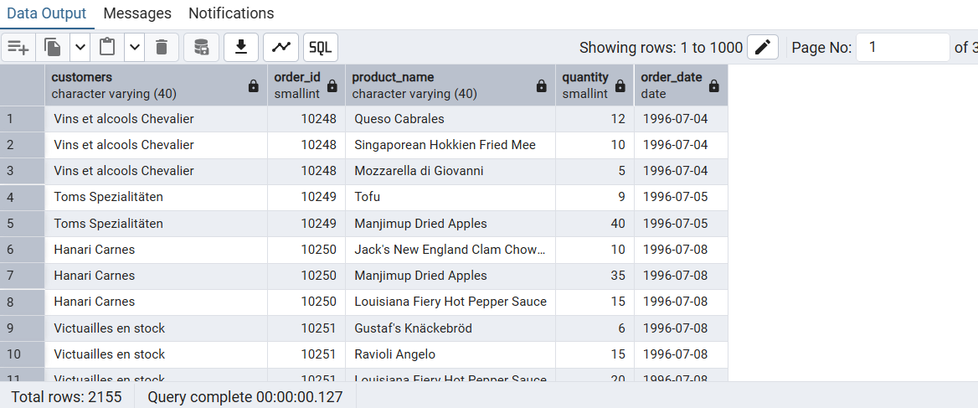

2. Show each order with customer, employee, shipper, and product info — even if some parts are missing. (Left Join)

Tables used: orders, customers, employees, shippers, order_details, products

SELECT

orders.order_id,

customers.customer_id,

(employees.first_name || ' '|| employees.last_name ) AS employees_name,

shippers.shipper_id,

products.product_name,

order_details.quantity

FROM

orders

LEFT JOIN customers ON orders.customer_id = customers.customer_id

LEFT JOIN employees ON orders.employee_id = employees.employee_id

LEFT JOIN shippers ON orders.ship_via = shippers.shipper_id

LEFT JOIN order_details ON orders.order_id = order_details.order_id

LEFT JOIN products ON order_details.product_id = products.product_id;

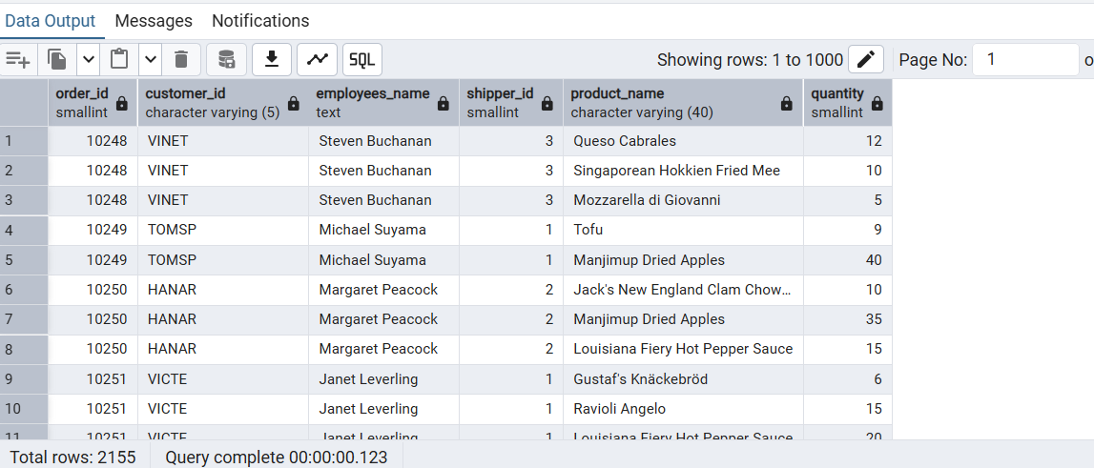

3. Show all order details and products (include all products even if they were never ordered). (Right Join)

**Tables used: order_details, products**

**Output should have below columns:**

orderid,

productid,

quantity,

Productname

SELECT

order_details.order_id,

products.product_id,

order_details.quantity,

products.product_name

FROM

order_details

RIGHT JOIN products ON order_details.product_id = products.product_id;

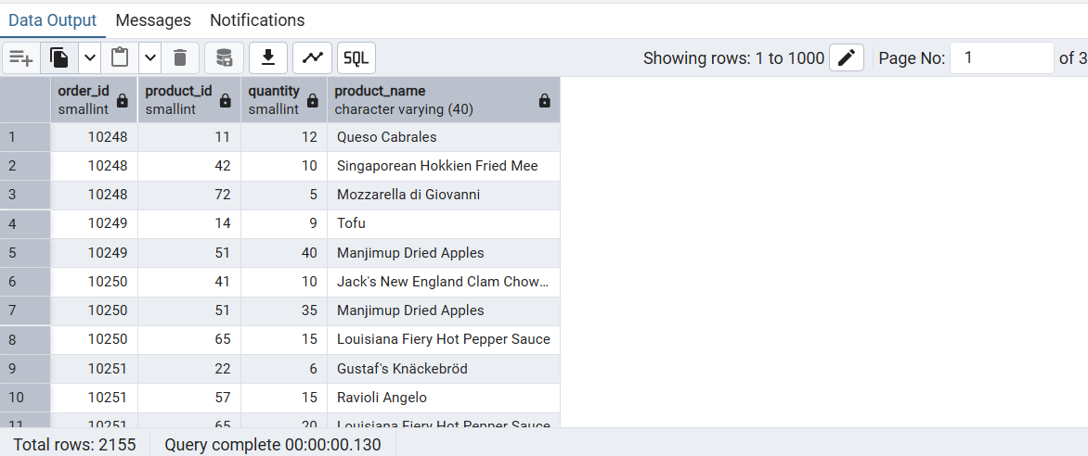

4. List all product categories and their products — including categories that have no products, and products that are not assigned to any category.(Outer Join)

**Tables used: categories, products**

**SELECT**

**categories.category_id,**

**products.product_name**

**FROM**

**categories**

**FULL OUTER JOIN products ON categories.category_id = products.category_id;**

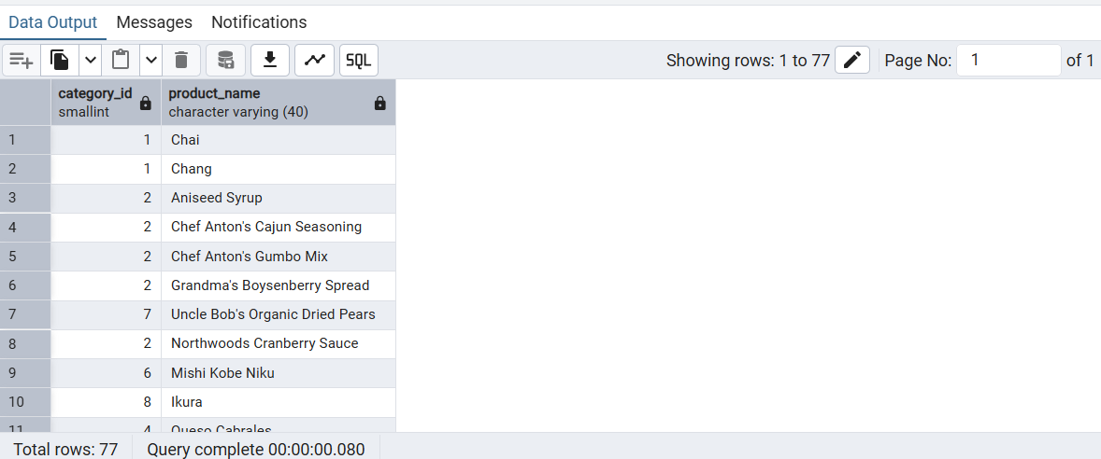

5. Show all possible product and category combinations (Cross join).

SELECT

products.product_name,

categories.category_name

FROM

products

CROSS JOIN categories;

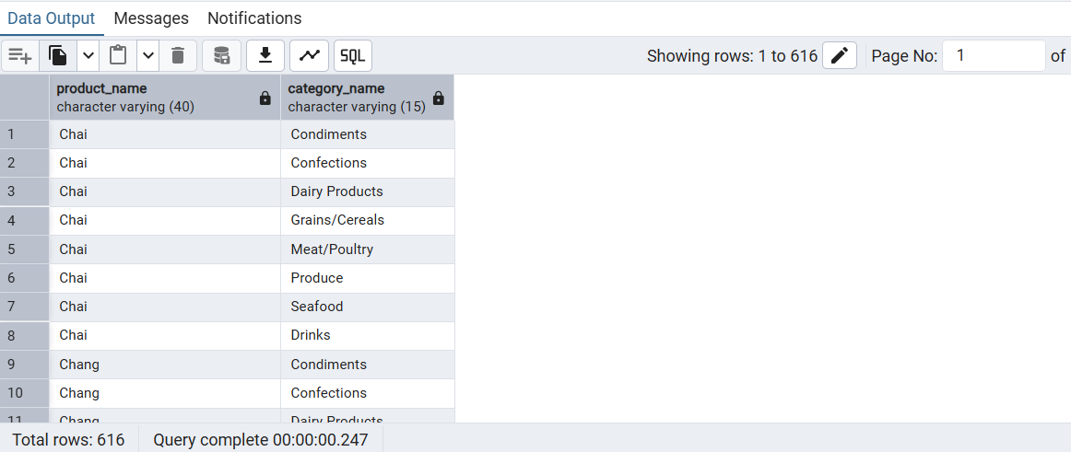

6. Show all employees and their manager(Self join(left join))

SELECT

e1.employee_id AS employee1_id,

e1.first_name || ' ' || e1.last_name AS employee1_name,

e2.employee_id AS employee2_id,

e2.first_name || ' ' || e2.last_name AS employee2_name,

m.employee_id AS manager_id,

m.first_name || ' ' || m.last_name AS manager_name

FROM

employees e1

JOIN employees e2

ON e1.reports_to = e2.reports_to AND e1.employee_id < e2.employee_id

JOIN employees m

ON e1.reports_to = m.employee_id;

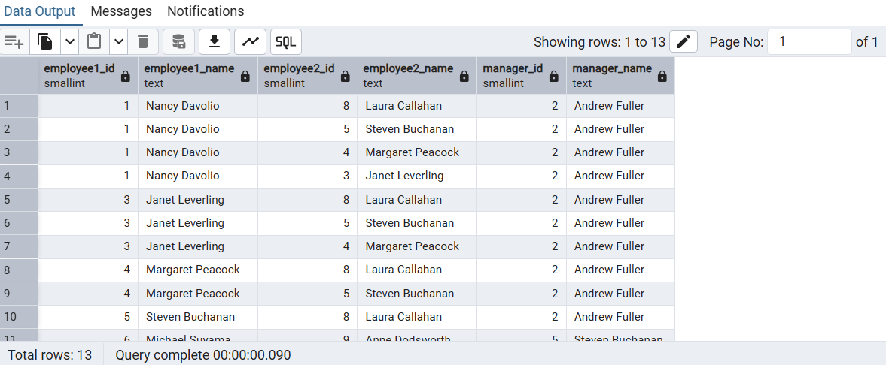

7. List all customers who have not selected a shipping method.

**Tables used:** customers, orders

**(Left Join, WHERE o.shipvia IS NULL)**

SELECT DISTINCT

customers.customer_id,

customers.company_name

FROM

customers

JOIN orders ON customers.customer_id = orders.customer_id

WHERE

orders.ship_via IS NULL;

